**RecruitYoung.com Review and Feedback/Recommendations**

1. Logo needs to be changed to something modern looking - it looks dated and does not fit with the design style for the rest of the site

2. Buttons - inconsistent style/sizing of buttons   
  
Good (http://www.recruityoung.com)

This button is well sized for the text, and makes use of gradient, similar to other design elements on the site.

: 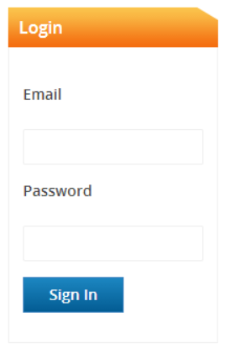

Bad (http://www.recruityoung.com/users/login):

The button is too small for the text here. Also, you have a mixture of 2D and 3D buttons. You should be consistent with these design elements.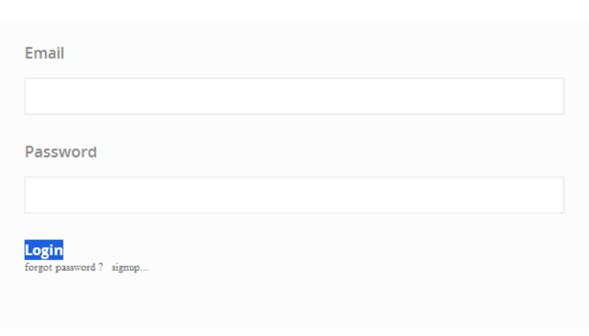

3. Same image as above - forgot password and signup links should a) make use of the same font family as the rest of the site, and b) should be presented in such a way that they look like links.

4. http://www.recruityoung.com/users/login

In the left panel you have the same content element repeated twice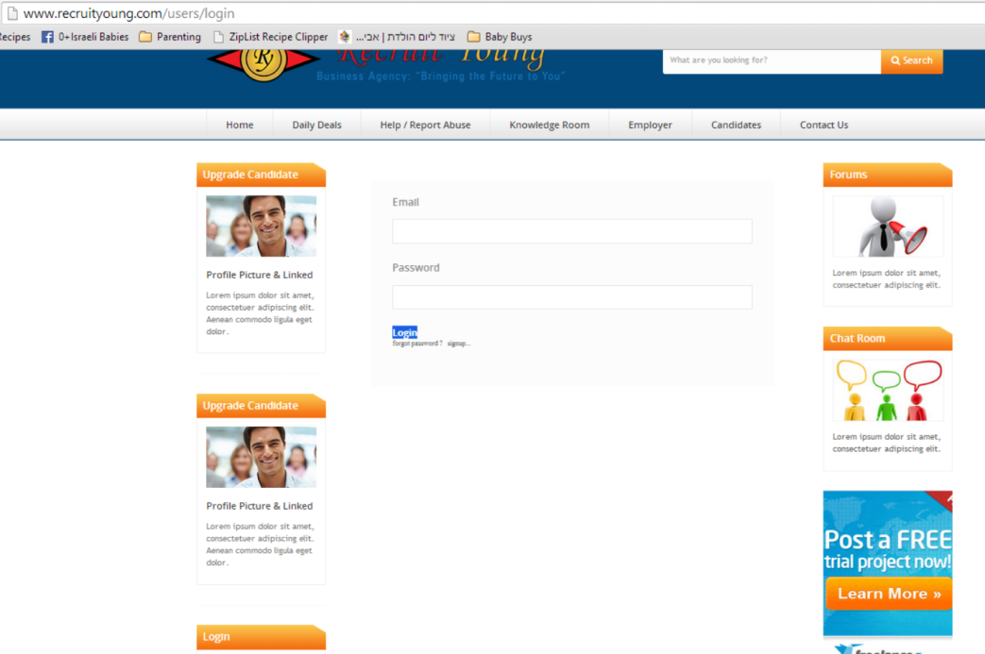

5. Forgot your password - field validation should look for [minimum 2 digits]@[minimum 2 digits].9minimum 2 digits] to ensure a valid email.  
  
Also, after getting it to attempt a reset by entering test@test, I received this error  
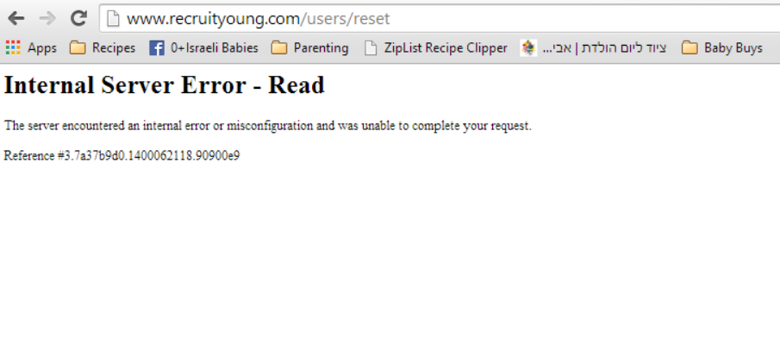

6. Forum - should include some sort of logo/header banner with back links to your site (otherwise your users get cut off from your site which will likely result in reduced conversion rates/engagement rates)

7. Forum - posting as a guest, it shows my user status as "Administrator" instead of Anonymous/Guest  
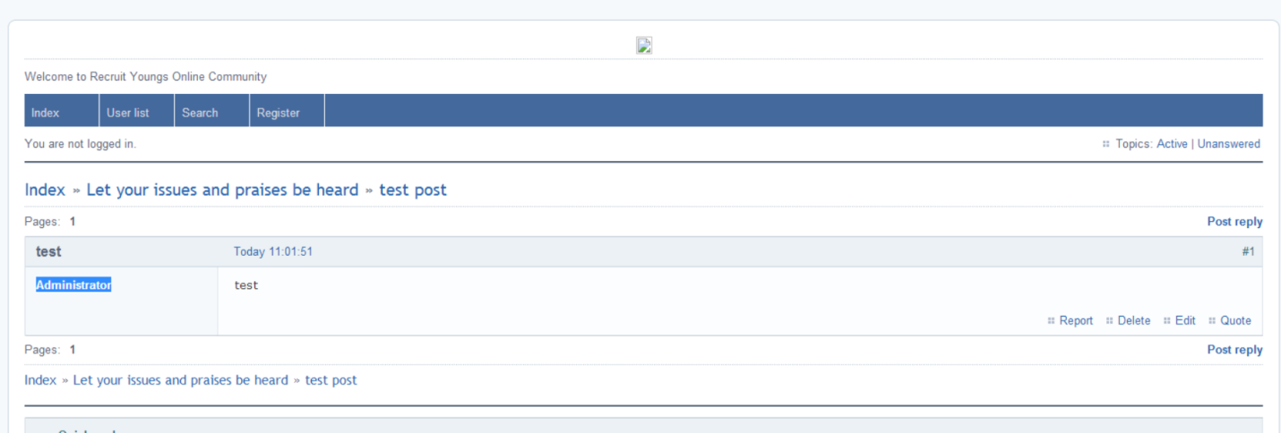

8. Forum - after posting my post 'test', doing a search for keyword = test did not produce results

9. Sign Up Page - The script font you are using is difficult to read (It took me significantly longer to process what is written there than normally would have taken) - choose a bold and clear font instead

10. Sign Up Page - The text of the opening sentence has several words with uppercase lettering that should be lowercase (see underlines, below) and has an incorrect symbol (see circle below - should be an appostrophe - use ASCII characters)  
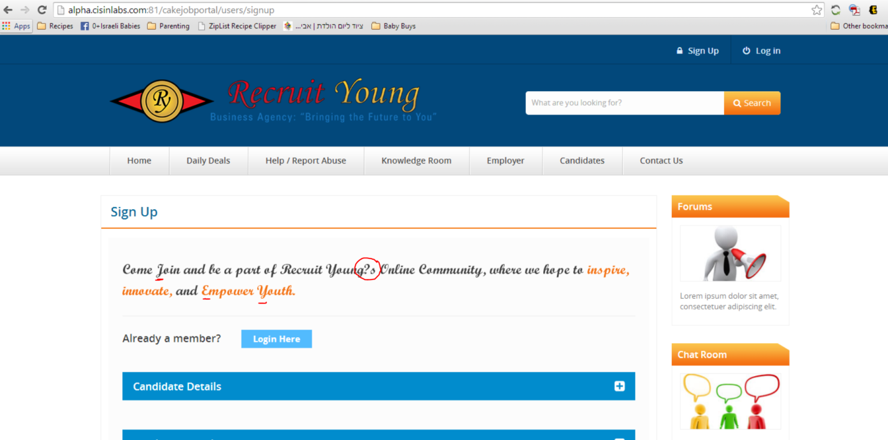

11. Again - ensure you are using consistent button design throughout your site (here is another 2D button, though with proper spacing. you need to just decide if you are going to use 2D or 3D/gradient buttons)

12.Candidate Sign Up - clicking on the link "Why do I need to enter my birth date" does not lead to an answer (instead, reloads so that in the Candidate Details box you have just that link and no other content)

13. Candidate Sign Up - entering incomplete info and submitting, you do not currently receive an error message (there is a red bar that flashed above the Candidate Details blue header, but with no text).   
  
I would highly recommend changing this to highlight the specific fields that were in error within the Details panel. (highlight the text fields with a red border, and specify in the error what was invalid about the fields) - consider putting error details above each invalid field to guide the user to quick completion. There is nothing more annoying than having to submit a web form 5 times before it is accepted

14. Candidate Sign Up - terms of use and privacy policy links do not have a destination defined.

15. Candidate Sign Up - combo box for Birth Date needs to be properly formatted (see image below) - field height is too large, and there is no scrolling bar, mean users can only navigate the list using the up/down arrows which is not comfortable since it skips through the options quickly, meaning you have to run through them slowly to find what you are looking for.  
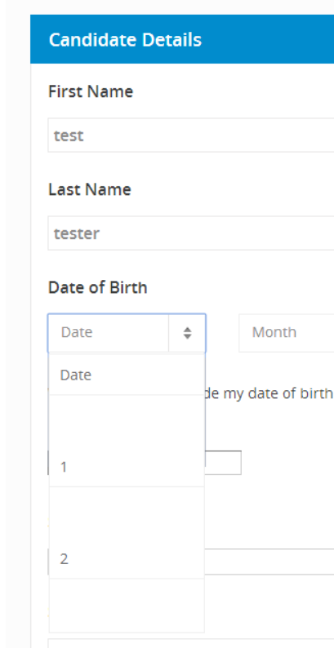  
16. Candidate Sign Up - Combo boxes for birthdates do not close when user clicks on another element or when a selection is made  
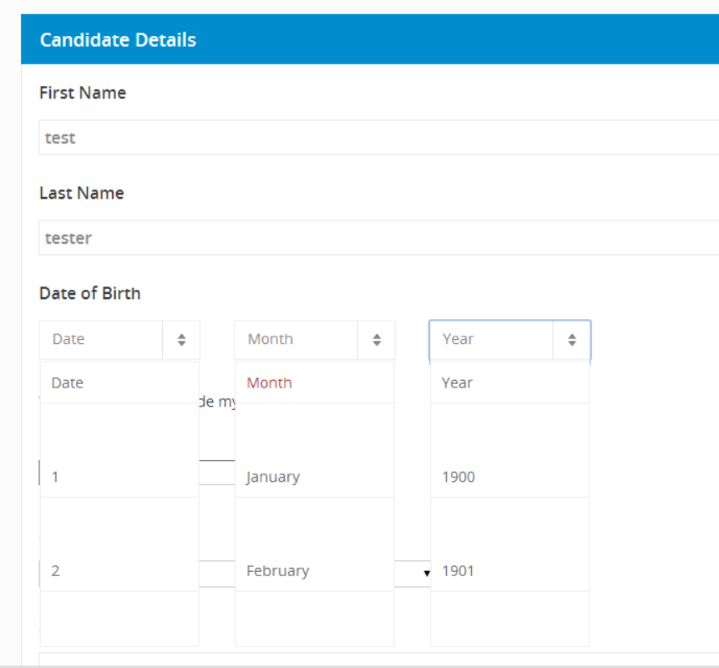

17. Candidate Sign Up - Birth Year - Nobody born in 1900 is going to be using your site. Neither is anyone born in 2010. This field should offer only valid birthdates for your users and should be ordered chronologically with most recent years first, not the oldest.

18.Candidate Sign Up - I tried to create a user and got an error  
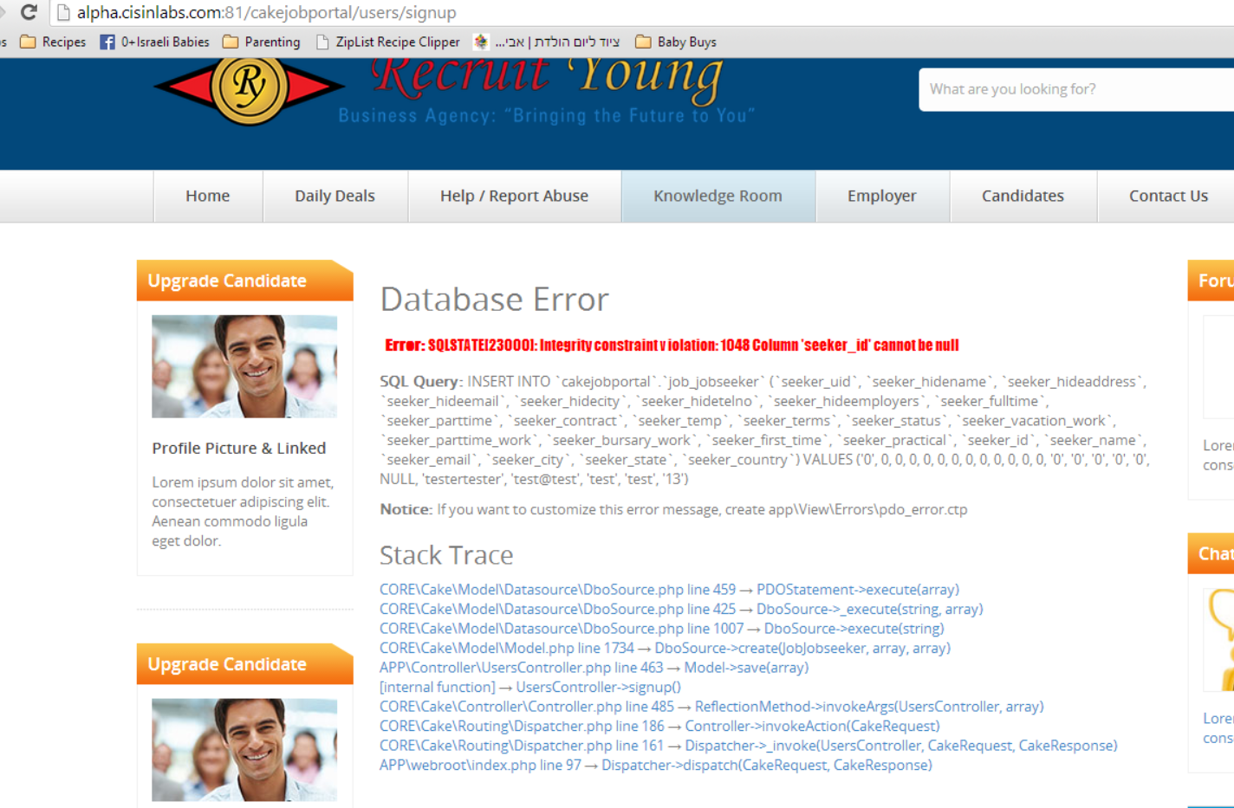

19. Employer Sign Up - You have a typo in the 'Terms and Conditions" link

20. Employer Sign Up - I would suggest including a category tag for Industry/Market Sector to allow you to provide candidates with an added filter variable when searching for employers

21. Employer Sign Up - I would also advise in making the Office Address several line items - you are already asking for the Country, State and City, so there is no need to include this huge text box. just include additional fields for Street Address and Zip Code

22. Page Footer - again, inconsistent use of design elements. You have two 2D (flat) buttons, and one 3D (gradient) - also the orange button is cut off at the left.  
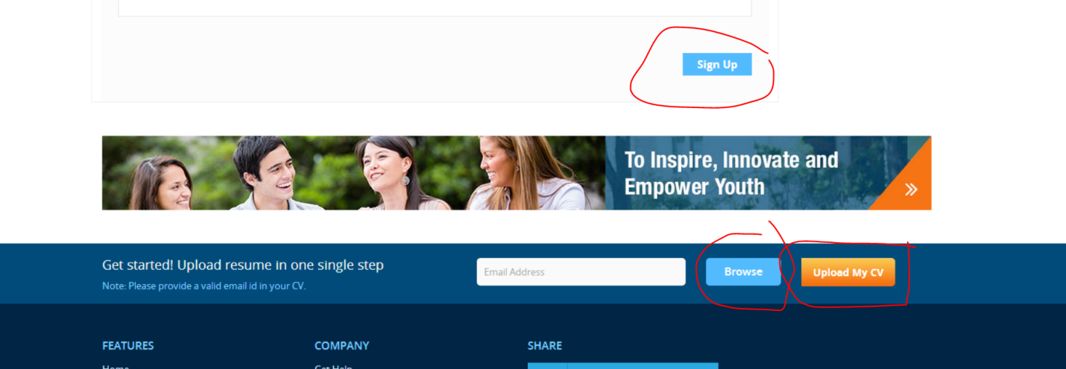

23. Referring to CV UPload in image above - you need to reconsider the format of this - You are not communicating the format of the file that can be uploaded (I selected a PSD and it did not give me an error)

24. Referring to CV UPload in image above - Once a file has been selected, there is no visual confirmation to the user. It just closes the popup

25. Referring to CV UPload in image above- test@test is accepted as an email (improper field validation)

26. Referring to CV UPload in image above submitting, I received an error

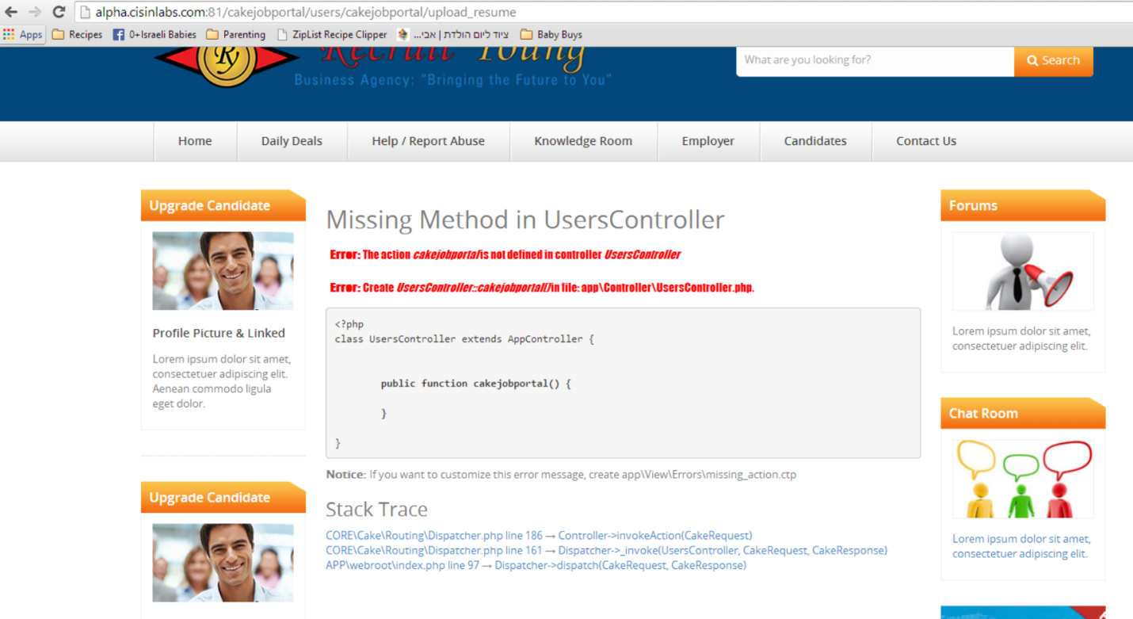

27. After receiving that error, I tried entering a email and password in the sign in box at the bottom left of the screen and again it looped back to the same error page  
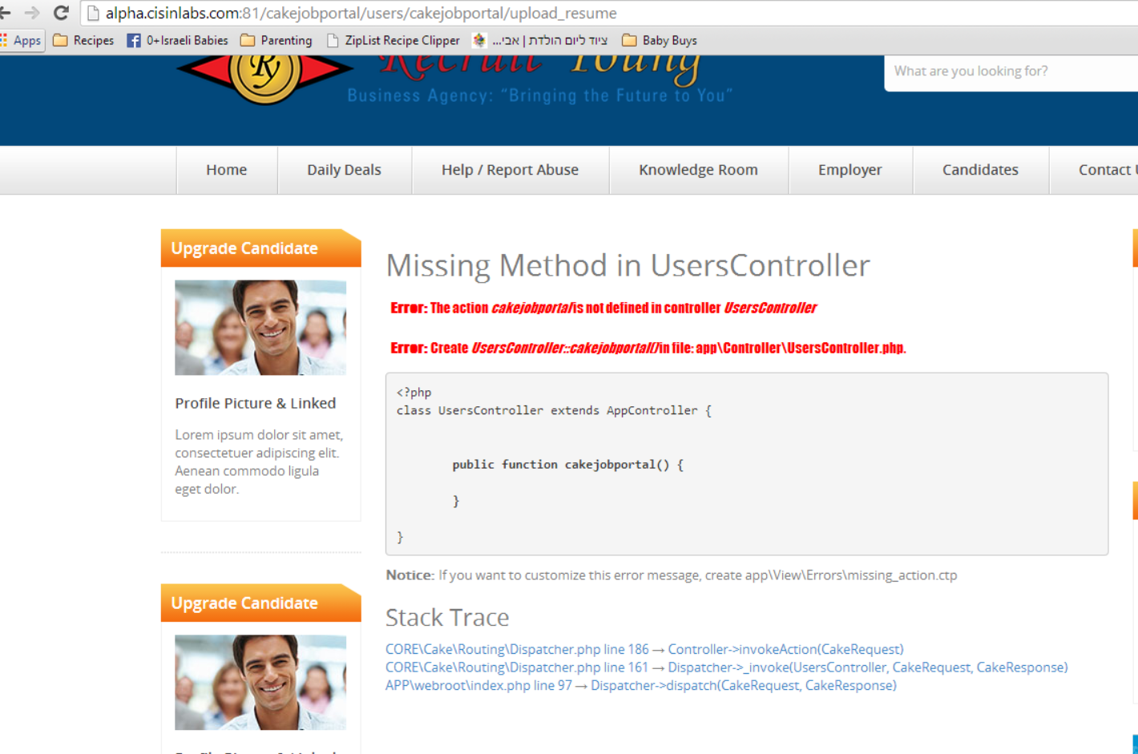

28. domain http://alpha.cisinlabs.com/ instead of recruityoung.com - I don't know if this is just for testing and temporary, but I would strongly advise on uniform domain usage for all pages.

29. Your Contact Us Form - leaving all fields blank except email which I entered as test@test, I get this error  
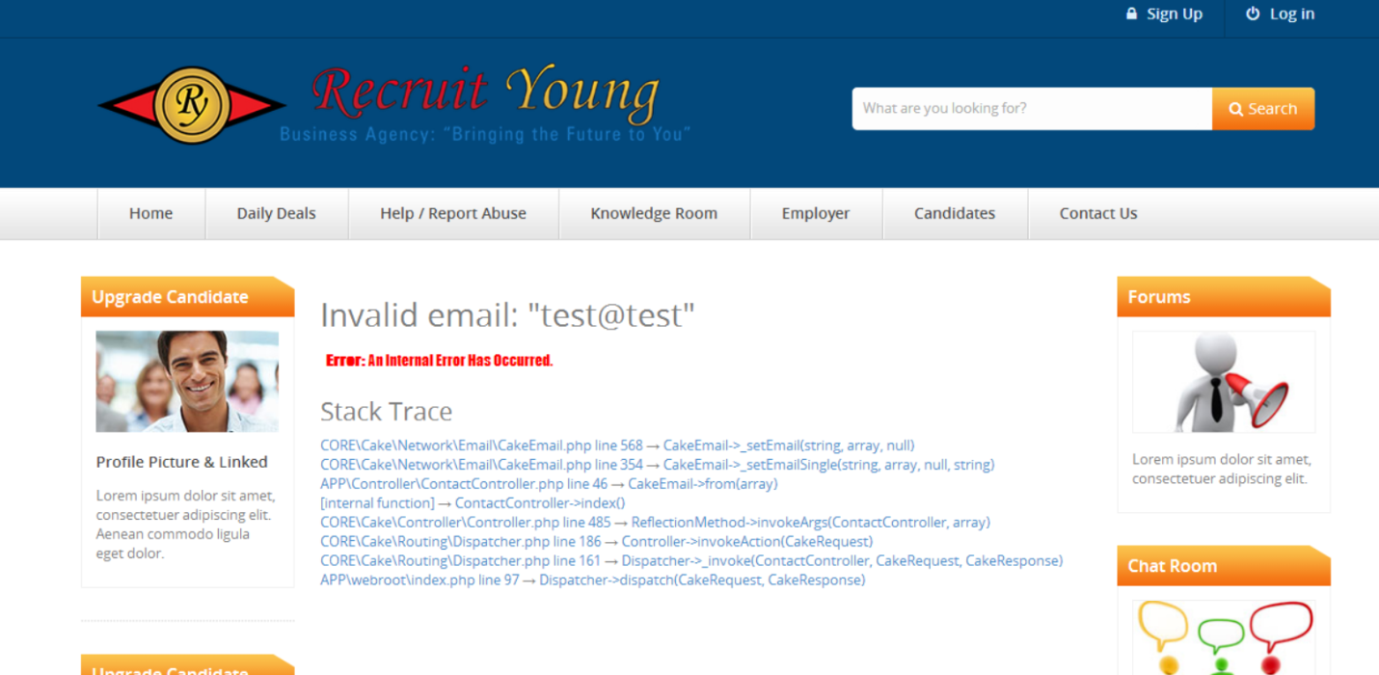

30. Contact Us Form - you should be validating fields in the same screen, not delivering errors on a new page.

31. Contact Us Form - You should add validation to ALL fields on that form to ensure you receive quality submissions. Also consider including a combo box with suggestions for the theme of the inquiry, and a capcha to avoid bot submissions.